FSU – Autumn 1 (Year A) Newsletter

Topic: **This Is Me** 

**Key Information**

**FSU staffing**

|  |  |  |  |  |
| --- | --- | --- | --- | --- |
| **Monday** | **Tuesday** | **Wednesday** | **Thursday** | **Friday** |
| Mrs Clarke  Mrs Ling | Mrs Clarke  Mrs Ling | Mrs Clarke  Mrs Ling | Mrs Clarke  Mrs Ling | Mrs Wells  Mrs Ling |
| Mrs Clarke  Mrs Ling | Mrs Ling  Miss Buckley | Mrs Clarke  Mrs Ling | Mrs Clarke  Miss Buckley | Mrs Wells  Mrs Walters |

**Homework** –All Reception children should complete a piece of homework from the homework grid each week and upload it weekly onto the *Tapestry App*.

**Reception Reading Books** are usually changed on a Monday and Wednesday.Records are checked on a Monday. This term there will be picture books for them to ‘retell’ in their own words to you. Please encourage descriptive vocabulary story sequencing and detail.

**Nursery sharing books** are changed once a week usually on a Thursday. (Those not in then will be changed on Wednesdays.)These stories should be read TO your child to develop their idea of how books work, their imagination and extend their vocabulary.

**PE** We will be taking part in Dynamo Cricket sessions on Tuesdays this term. (Please send children to school wearing normal school uniform and ensure they have Charlton PE kit to change into in school.)

**Forest School** is on Thursday afternoons for this term. (Please make sure they have wellies and waterproofs and a bag with a change of clothes in school.)

**Literacy**

Our stories this term include: **The Colour Monster** and **The Colour Monster Goes to School** by Anna Llenas; **You Choose** by Nick Sharratt & Pippa Goodhart and **Big Book of Families** by Catherine and Laurence Anholt. We will also be looking at some stories about going to the dentist and Non fiction texts about Harvest and Senses.

**Phonics**

Reception Children will be learning to read and write Set 1 Sounds using the Read Write Inc. phonics scheme: m a s d t i n p g o c k u b f e l h sh r j v y w th z ch qu x ng nk.

For more information on how to pronounce these with your children click this link fora video by RWInc. <https://www.youtube.com/watch?v=UCI2mu7URBc>

Nursery Children will be developing their phonological awareness by discriminating between different environmental and instrumental sounds as well as exploring body percussion.

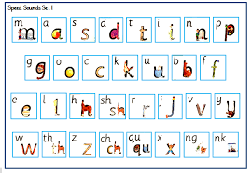

**Maths**

Reception Children will be recapping the five counting principles: 1:1correspondance, comparing groups, stable order, cardinal principle (last number said equals total number)and abstract principle (counting objects without touching or moving them.) Then developing an understanding of the value, composition and ways to represent the numbers 1, 2 and 3. They will also compare size, mass and capacity of things and types of pattern.

Nursery Children will be counting 12345 including reciting, using fingers and objects to represent before practising being able to recognise up to three objects by sight without counting (subitising). They will then make comparisons between objects relating to their size, length, weight and capacity. Next develop the ability to talk about and identify patterns around them.

**Understanding the World**

Our topic of ‘This is Me’ will get the children to think about themselves, their family history and celebrate the differences between people. As Autumn arrives we will be focusing on our natural environment, Harvest and the importance of farming in our local community. We will also introduce the science topic of senses by going on a senses walk before finally reminding ourselves of how to look after our oral health, particularly deciding which foods are always good and which are sometimes good choices.

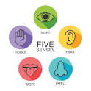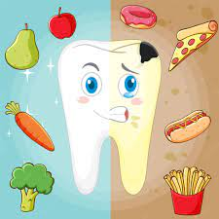

**RE**

In RE we will celebrate Harvest and Diwali as well as hearing some Old Testament stories from the bible and introducing the school vision-linked story of the Mustard Seed (Matthew 13 verses 31-32)

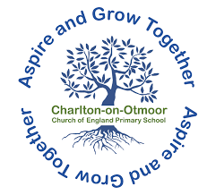

**Expressive Arts and Design**

This half term amongst other art and craft we will be drawing self portraits including focusing on mark making, developing detail, representing emotions, use of colour and colour mixing. Also developing fine motor control and muscles to hold pencils and use of a range of small tools, including scissors, paint brushes and cutlery. In Music we will be investigatingrhythm and non-pitched percussion.

**PSHE**

In PSHE this half term, children will be introduced to the school value of **Love.**

